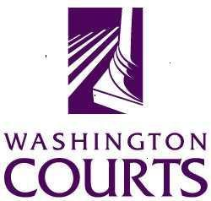
Court Improvement Training Academy

Dependency Court Practice for Judicial Officers

March 4-6, 2019
Vancouver, Washington

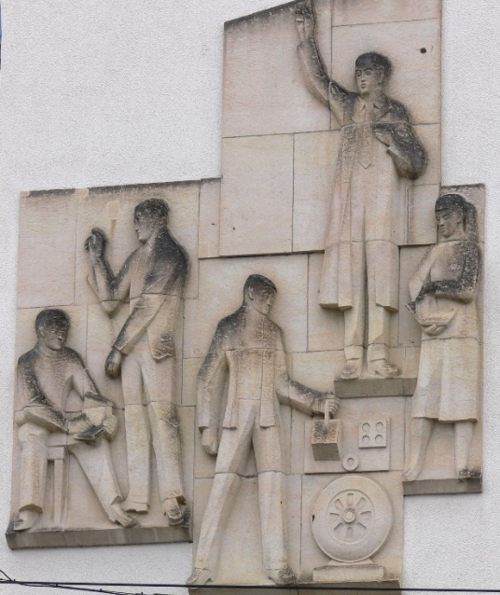
The Court Improvement Training Academy will present a dynamic three-day training program on child abuse and neglect hearings that promote safety, due process, timely permanency, and well-being for children and families.

The training will take place at the

Heathman Lodge
7801 NE Greenwood Dr
Vancouver, WA 98662

Agenda

Day 1 – Monday, March 4, 2019

7:30 – 8:00 am Registration.

8:00 – 9:00 am Welcome and Introductions. Orientation to the overall agenda, and introductions of participants attending the training that will include a small opportunity to get to know each other and to support our shared learning over three days.

9:00 – 10:15 am Culture of Foster Care. An updated presentation by the Mockingbird Society, a foster youth advocacy organization providing participants with perspective and empathy for the youth experience in the foster care system.

10:15 – 10:30 am Break.

10:30 – 12:00 pm ABA Child Safety: A Guide for Judges and Attorneys (Part 1). The Child Safety Guide presents a common language and thought structure that serves as a bridge from field-based social work practice to courtroom-based legal standards, helping all participants in the dependency court engage in safety assessment and planning, and case planning, all toward serving the needs of the child and family with predictability and clarity. In Part 1, we will address an overview of the model, and then discuss gathering information for safety assessments, assessing safety, safety planning, and articulating conditions for return.

12:00 – 1:00 pm Lunch will be provided.

1:00 – 2:00 pm Law of the Hearing and Judicial Perspective: Shelter Care Hearings. Commissioner Shane Silverthorn, Yakima County Juvenile Court, will discuss the law as it relates to shelter care hearings in WA State, and share his perspectives on conducting shelter care hearings, including providing a checklist of issues to address at the hearing and engaging discussion among participants.

2:00 – 2:15 pm Break.

2:15 – 3:00 pm Mock Hearing: Shelter Care. Commissioner Silverthorn will preside over a mock shelter care hearing.

3:00 – 3:30 pm Reflection. Participants will have the opportunity to reflect on the shelter care hearing, including the application of the Safety Guide, the law, checklists and other perspectives, and the conduct of the mock hearing. Priority will be given to reflections of the parents who participate in the mock hearing.

3:30 – 4:30 pm Judicial Leadership in Dependency Court. An interactive hour with Retired Commissioner Royce Moe from Spokane County Juvenile Court, and Judge Mary Sue Wilson from Thurston County Juvenile Court, discussing aspects of court leadership, examples of leadership in WA State dependency courts, and discussion among participants about how to engage the leadership role in your jurisdiction.

Day 2 – Tuesday, March 5, 2019

8:00 – 8:30 am Introduction and Overnight Mail. Introduce the day and consider any new thoughts, reflections, or questions since we adjourned yesterday.

8:30 – 9:45 am Visitation: Law, Policy, and Science. A focused look at visitation, considering the science behind building and maintaining relationships between family members, basing visitation orders on considerations of safety, understanding policy, and applying the law.

9:45 – 10:00 am Break.

10:00 – 10:45 am Safety Guide – Part 2. This session will cover case planning that is based on the assessment of safety, in preparation for adjudication (see below).

10:45 – 11:45 am Law of the Hearing and Judicial Perspective: Presentation of Fact-Finding and Disposition Orders. Judge Amber Finlay, Mason County Juvenile Court, will discuss the law as it relates to a presentation of agreed Fact-Finding and Disposition Orders; and share her perspective on conducting the hearing, including providing a checklist of issues to address at the hearing and engaging discussion among participants.

11:45 – 12:45 pm Lunch will be provided.

12:45 – 1:30 pm Mock Hearing: Presentation of Agreed Fact-Finding and Disposition Orders. Judge Finlay will preside over a mock hearing where agreed Fact-Finding and Disposition Orders are presented.

1:30 – 2:00 pm Reflection. Participants will have the opportunity to reflect on the presentation of orders, including the application of the Safety Guide, the law, checklists and other perspectives, and the conduct of the mock hearing. Priority will be given to reflections of the parents who participate in the mock hearing.

2:00 – 2:15 pm Break.

2:15 – 4:45 pm ACEs and Resilience: Understanding the Impact of Trauma and Tools to Use From the Bench. Tif Junker, adoptive parent, and Linda Segur, Parent Child Assistance Program, will provide an overview of current NEAR (Neurobiology, Epigenetics, ACEs and Resilience) research and how it shows up in dependency court. Participants will receive tips for promoting hope and supporting recovery in children and parents who have experienced trauma.

Day 3 – Wednesday, March 6, 2019.

8:00 – 8:30 am Introduction and Overnight Mail. Introduce the day and consider any new thoughts or reflections since we adjourned yesterday.

8:30 – 10:00 am ICWA: Law, Regulations, Policy, History, and Practice.

10:00 – 10:15 am Break.

10:15 - 11:15 am Family First Prevention Services Act (FFPSA).
Judge (Ret.) Maurice Portley and Barb Pryor, Policy Analyst, from Casey Family Programs will discuss the intention behind the law, how it functions, and direct implications on dependency court practice, including enhancements to prevention efforts and changes to the use of group care (“quality residential treatment programs”).

11:15 – 12:15 pm Safety Guide Part 3. This session will discuss how to assess whether it is safe to return children to their parent’s custody under a safety plan, progress on the case plan, and when it is time to dismiss jurisdiction. There will also be time to discuss what changes to your court’s procedures or forms would assist in promoting fidelity to safety-oriented practice.

12:15 – 1:00 pm Lunch will be provided.

1:00 – 2:00 pm Law of the Hearing and Judicial Perspective: Review Hearing. Judge Elizabeth Berns, King County Juvenile Court, will discuss the law as it relates to a review hearing and share her perspective on conducting the hearing. Judge Berns is also an experienced Family Treatment Court Judge and will add perspective on reviewing dependency cases from the treatment court model perspective.

2:00 – 2:15 pm Break.

2:15 – 3:00 pm Mock Hearing: Review. Judge Berns will preside over a mock review hearing.

3:00 – 4:00 pm Reflection. Here, we will invite reflection on the mock review hearing, and then on the three days overall – including discussion of immediate changes to practice or procedure judicial officers think they can make as a result of the training.

