Assessing Safety

Threats:
Specific, observable, out of control, immediate or imminent, and severe

Vulnerability:
Is this child vulnerable to this threat?

Protective capacity:
Behavioral, cognitive, and emotional characteristics of the parent

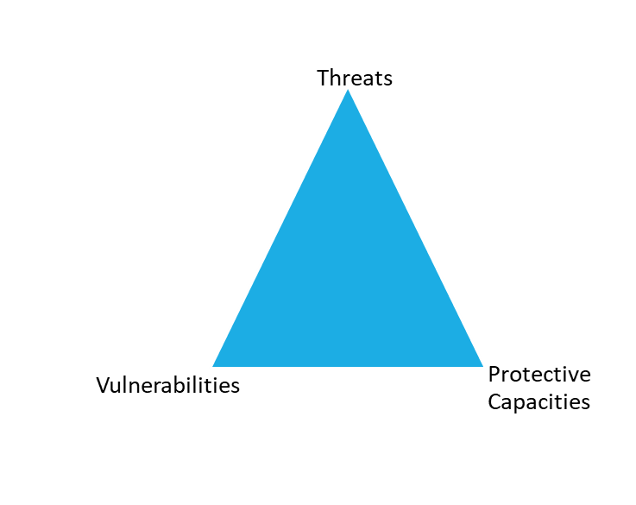
__________________________________________________________________
Safe = no threats, child is not vulnerable to threat, or there is sufficient protective capacity to control threats

Not safe = threats exist to which child is vulnerable,
and parents have insufficient protective capacity to control threats

