Sunday | Monday | Tuesday | Wednesday | Thursday | Friday | Saturday
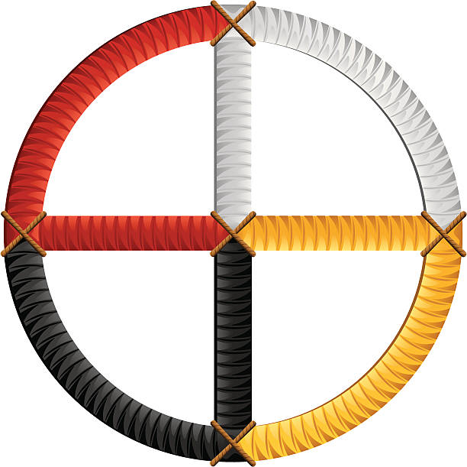
Life Choices
Mental/Emotional
Physical

NAME

DATE:_______________ _______________
Social/Cultural
Spiritual

